SmartCare v0.4 - Domain Implementation Workbook
Week 7 student resource

1. UML-to-Code Trace
UML element | Python element | Implemented? | Notes
Patient attributes | Patient.__init__(patient_id, name, contact_number, date_of_birth) | Yes | Blank text: ValueError  DOB not a date: TypeError  status starts "active"
createRecord() | create_record() | Yes | Sets status "active"
updateRecord() | update_record(name, contact_number) | Yes | ValueError if archived
archiveRecord() | archive_record() | Yes | Sets status "archived"  Object is kept
Practitioner attributes | Practitioner (practitioner_id, name, specialty) | Yes | Blank values: ValueError
updateAvailability() | update_availability(day_or_date, start_time, end_time) | Yes | ValueError if start_time >= end_time
viewSchedule() | view_schedule(appointments) | Yes | Filters the supplied list by practitioner
viewPatientRecord() | view_patient_record(patient) | Yes | Returns a dict summary
Appointment attributes | Appointment.__init__(appointment_id, patient, practitioner, appt_date, appt_time) | Yes | Blank ID: ValueError  Wrong date/time type: TypeError  status starts SCHEDULED
book() | book(existing_appointments) | Yes | Clash: ValueError  Else CONFIRMED and patient.record_appointment(self)
reschedule() | reschedule(new_date, new_time, existing_appointments) | Yes | Only from SCHEDULED/CONFIRMED. Old slot restored on clash.
cancel() | cancel() | Yes | Illegal transition: InvalidStatusTransitionError.
checkConflict() | check_conflict(existing_appointments) -> bool | Yes | Same practitioner, date, time. Skips itself and CANCELLED.
AppointmentStatus | AppointmentStatus(Enum) | Yes | SCHEDULED, CONFIRMED, COMPLETED, CANCELLED, NO_SHOW.
Exception (not in UML) | InvalidStatusTransitionError; _ALLOWED_TRANSITIONS; _set_status() | Added | Enforce legal status transitions.
Availability class | None | No | Not implemented; slots held in Practitioner. _availability_slots.

2. Domain Invariants
Class | Invariant / rule | How protected
Patient | patient_id, name, contact_number not empty. | __init__ raises ValueError.
Patient | date_of_birth must be a datetime.date. | isinstance check; raises TypeError.
Patient | Archived record cannot be updated. | update_record() raises ValueError.
Patient | Records are archived, not deleted. | archive_record() only sets status.
Patient | History changed only through Patient. | Private _appointment_history; record_appointment(); history view returns a copy.
Practitioner | practitioner_id, name, specialty not empty. | __init__ raises ValueError.
Practitioner | Slot start must be before end. | update_availability() raises ValueError.
Appointment | appointment_id not empty; date and time are real date/time objects. | __init__ raises ValueError / TypeError.
Appointment | Status starts SCHEDULED; only legal transitions allowed. | Enum, _ALLOWED_TRANSITIONS, private _set_status(); raises InvalidStatusTransitionError.
Appointment | No double booking of a practitioner. | book() and reschedule() call check_conflict(); ValueError on clash.
Appointment | Cancelled appointments stay as objects and free their slot. | No delete; check_conflict() ignores CANCELLED.
Appointment | Failed reschedule leaves the appointment unchanged. | Old date/time restored before raising.

3. Composition / Inheritance Decisions
Relationship | Decision | Rationale
Appointment - Patient | Association | Not an is-a relationship. Patient exists independently of appointments.
Appointment - Practitioner | Association | Not an is-a relationship. Schedule is derived by filtering, not stored on Practitioner.
Doctor - Practitioner (hypothetical) | No inheritance | Doctor would add no behaviour specialty is an attribute.
Clinic - Appointment (hypothetical) | Composition | Appointments belong to a clinic. No Clinic class in v1.
Appointment - Bookable (AI draft) | Rejected | Base class held one method, was used by nothing and is not in the UML.

4. AI Pair-Programming Record
AI contribution | Conforms? | Decision | Reason | Verification
AppointmentStatus as plain class of strings | No | Reject | Prompt required an enum. | Refactored to Enum.
room_number attribute | No | Reject | Not in approved UML. | Removed from constructor.
Bookable base class | No | Reject | Unused; not in UML. | Removed.
Appended to patient._appointment_history | No | Modify | Mutated another object's private state. | Replaced with patient.record_appointment(self).
Created practitioner.schedule | No | Reject | Attribute not in Practitioner design. | Removed.
_notify_patient() wrote notifications.log | No | Reject | Prompt said no notifications. | Manual check confirmed file was written by the draft; removed.
Bare except; returned True/False | No | Modify | Failure not distinguishable from success. | Duplicate booking now raises ValueError.
No status transition checks | No | Modify | Cancelled appointment could be cancelled or rescheduled again. | Second cancel and reschedule-after-cancel now rejected.
Cancelled appointments counted as conflicts; self not excluded | No | Modify | Cancelled slot should be free. | Added CANCELLED exclusion and other-is-self check.
Blank appointment_id accepted | No | Modify | Patient and Practitioner reject blank IDs. | Validation added to __init__; blank ID now raises ValueError.
Method names book, reschedule, cancel, check_conflict | Yes | Accept | Match approved UML. | Kept.

5. Updated UML
Insert updated UML only if implementation revealed a justified design change. Explain every change.
Changes on the diagram and listed below.

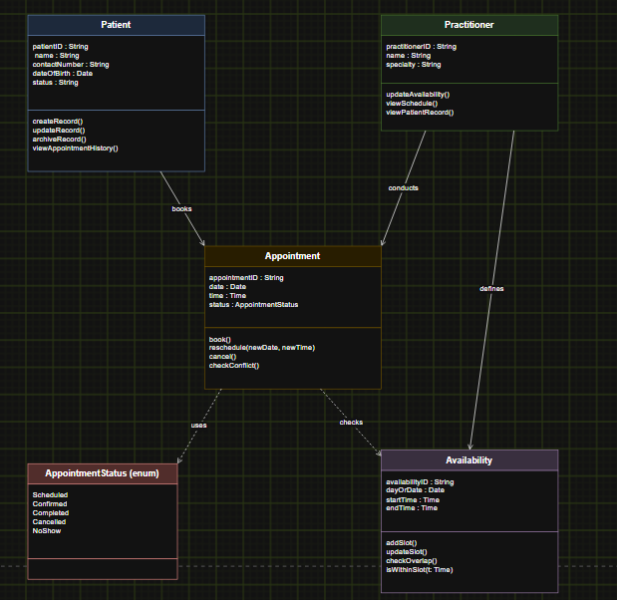
Made with draw.io

Change | Type | Why
Appointment operations corrected to book, reschedule, cancel, checkConflict. | Correction | Old diagram repeated Practitioner's operations.
Practitioner 1 - 0..* Appointment association added. | Correction | Required by CRC cards and used in code; missing from diagram.
Patient.recordAppointment(appointment) added. | Addition | Controlled way to update history; avoids editing private state.
book, reschedule, checkConflict take existingAppointments; checkConflict returns bool. | Signature | No database; caller supplies the list.
InvalidStatusTransitionError and private setStatus() added. | Addition | Protects status transitions.
Confirmed appointment returns to Scheduled on reschedule. | Decision | UML was silent on this case.

